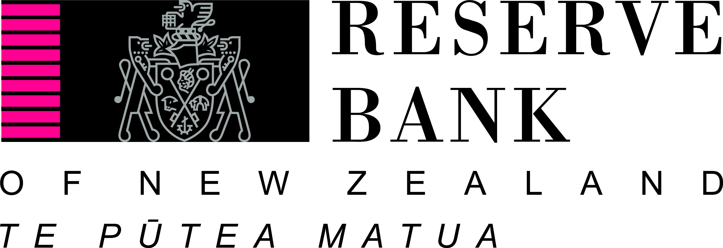

Handling banking failures

A speech delivered to the Institute of Directorsin Wellington

On 11 April 2013

By Toby Fiennes, RBNZ Head of Prudential Supervision

Embargoed to 10am, 11 April 2013

Handling banking failures

Recent events in Cyprus revive memories of actual and threatened bank runs during the Global Financial Crisis (GFC). They also cause understandable concern to people all over the world, New Zealand included, about how safe their banks are.

I’m going to discuss the tools that the Reserve Bank and other authorities have for dealing with bank crises. There has been much discussion recently of our Open Bank Resolution (OBR) tool, and of whether New Zealand ought to guarantee or insure bank retail deposits. I’ll address both matters.

Before doing so, though, I want to stress that we at the Reserve Bank believe the New Zealand banking system, and the individual banks within it, are in good health. They have robust balance sheets and are well-positioned to withstand pretty severe stresses.

In the Reserve Bank we think deeply about how to handle stresses in the financial system, so that the country can be well-prepared if the worst does happen. It is like regularly checking your earthquake survival kit at home to make sure it contains everything you might need.

So this talk is not about what will happen – it’s about how the Reserve Bank and other authorities may respond in the extremely unlikely event of a seriously distressed bank or banking system. In this, we have drawn from the real life lessons of countries overseas.

Principles

Three simple principles guide us in thinking about how to deal with the next financial crisis.

The first is that the next one will be different. Take for example the entirely domestic US Savings and Loan failures in the 1980s, the Asian crisis of confidence of the late 1990s, and the GFC of 2007-2009. All had very varied causes and all required very different responses from the authorities. The onus is therefore on the authorities to have a toolkit that’s as flexible as possible and doesn’t assume that we will be “fighting the last war”.

So the first principle is that our range of responses should be as flexible as possible and ideally able to be applied to crises of whatever cause and severity.

Failure resolution tools have two objectives, and these underlie the other two principles.

Above all, we need tools that can deal with the crisis on hand as effectively and with as little damage to the financial system as possible.

We also need a crisis resolution framework that reduces the likelihood of a crisis, rather than increases it. Unfortunately, it is possible to do the latter, for example, if the authorities fostered expectations that a failed bank would expect to receive full government support (or “bail-out”). This is called a “moral hazard” problem in that, under such a scenario, the incentive for the bank’s management, shareholders or creditors and depositors to minimise the risks of failure is much reduced. Such stakeholders may take more risks if they believe the Government will provide taxpayer support or underwrite losses.

There is also an overarching need for everyone to recognise that, during a crisis, we are not in a first-best world. There are no easy solutions and when a bank goes under, somebody is going to lose money. We do what we can within reason to prevent crises (our capital and liquidity rules are key quantitative measures and are set conservatively, and we also supervise the banks). The financial system we oversee can be likened to a ship with excellent state-of-the-art navigation and safety features; but when, despite all that, the ship hits an iceberg, we have to take stock of the serious damage to the ship and deal with the situation at hand.

For the rest of this presentation I assume that the worst has happened – the ship has hit the iceberg and there is no third party rescue (e.g. takeover by another bank) on the horizon.

Open Bank Resolution

A key objective of any resolution framework is to ensure that the financial system continues to function as smoothly as possible. This means keeping payment systems open so that people and businesses can transact with one another.

That is the primary purpose of our Open Bank Resolution or OBR tool. It is, as its name implies, a mechanism for reopening a bank very rapidly after a failure event. There is detailed information on our website about the process so I won’t go through it in detail now. In outline, when a bank is in trouble and we think it is unlikely to be able to meet its obligations in full and / or on time, it will be placed into statutory management. The statutory manager will legally freeze the bank’s liabilities.

The basic idea is to release transaction accounts to the bank’s customers as swiftly as possible so they can carry on making and receiving payments. Instead of their accounts being frozen for a lengthy period as they would under a conventional liquidation, a proportion would be unfrozen and released for the start of the next business day (with a government guarantee to prevent further runs on the bank). Non-transaction accounts would be released, also in the same proportion, in line with their maturity. The frozen funds would be released in whole or in part as resources are available. Banks are required to pre-position their systems by 30 June 2013 so that this process can operate smoothly if it ever needs to be activated.

So OBR is about keeping a bank open and providing the government with real alternatives to liquidation or full taxpayer bailout – both of which may be totally unpalatable. It facilitates a rapid and orderly resolution of a bank failure. It does so without changing our basic legal framework around ranking of creditors in a wind-up or insolvency. In particular:
- It does not change the fact that depositors’ and other creditors’ funds are at risk. It is a well-established legal principle that people stand to lose money if a business that owes them money cannot meet all its obligations. Banks are the same as any other business in this regard.
- It does not change the ranking of creditors. Shareholders will be the first to lose their investment. Once shareholder funds are exhausted, subordinated creditors bear losses, followed by all other unsecured creditors on a pari passu basis, meaning that those with an equal legal claim get equal treatment. This is the same as in a liquidation.

Two features of OBR make it particularly well-suited to the principles for crisis resolution I outlined earlier. They are:
- Its flexibility. OBR deals with the immediate crisis, including payments and liquidity issues around failing banks, without closing off long-term solutions.
- It reduces moral hazard. Bank shareholders, management and investors know that in the case of bank failure the authorities have a viable option that would put their stakes at risk. The mere presence of OBR in the toolkit will impact expectations of government support.

OBR aligns well with the “Key Attributes of Effective Resolution Regimes for Financial Institutions”, issued by the Financial Stability Board (FSB) in October 2011. We assessed OBR and the New Zealand framework against these key attributes. The FSB attributes include: ensuring continuity of services and payments, not relying on public support, speed and allocating losses in a manner that respects the normal hierarchy of claims. OBR scores well against all of these criteria.

Of course OBR would not be the only option in a crisis. A government could still decide to bail out a bank or allow a bank to go into liquidation, if it felt the risks of doing so were small. But it is critically important to have a tool such as OBR in the crisis toolkit, to maximise options for the authorities on the day.

Deposit insurance

I’ll now turn to the position of retail depositors in a bank crisis, including how they are treated under OBR.

It is important to emphasise that OBR and deposit insurance are not in any way alternatives. OBR is also applicable in a world where we have deposit insurance as in one where we don't. Deposit insurance usually involves the establishment of an insurance fund, to which banks contribute. There are many different variations on, and within, that basic framework, but OBR can cope with all of them. For example, if there’s an insurance fund, the fund itself could stand as a creditor in the OBR. This is how the FDIC (the US deposit insurer) is treated in failed US banks.

New Zealand does not currently have any form of deposit insurance or deposit guarantee. This position was confirmed by the Minister of Finance in 2011 (http://www.beehive.govt.nz/release/maintaining-confidence-financial-system). There are three reasons for this position:
- Deposit insurance is not always effective in preventing bank runs by retail depositors. UK-based Northern Rock suffered a classic retail run in 2007, despite a deposit insurance scheme being in place.
- Deposit insurance is hard to price accurately and fairly; and brings with it difficult boundary issues. Should it be just for banks – as is currently the case for OBR – or should it also include finance companies, building societies and credit unions? How would we ensure that the least risky banks do not end up subsidising the more risky?
- Deposit insurance will increase moral hazard, making the banks more susceptible to failure, which brings with it the need for more, costly regulation.

Where losses suffered by a bank are very large, the magnitude of claims may overwhelm the resources of a deposit insurance fund. This was the case with the Savings and Loan failures. The ultimate cost has been estimated at $US160billion, about 25 times the $US6.3 billion in reserves held by the deposit insurer at the end of 1982. In the end, US taxpayers were required to back up the commitment extended to insured depositors of failed institutions.

It should also be noted that deposit insurance is likely to be a one-way street: once it is put in place, it would be difficult to remove.

On the other hand, some form of depositor protection arrangement may make it easier for the government of the day to impose a resolution such as OBR that does not involve taxpayer support – in effect the political “noise” from depositor voters is dealt with.

A recent paper by World Bank staff assessed how deposit insurance affected bank risk, drawing on data across 96 countries during the pre-crisis (2004-06) and crisis (2007-09) periods. They conclude that the “moral hazard effect” dominates in good times, in that the existence of a deposit insurance scheme does lead to riskier behaviour by banks. During a crisis, bank risk is lower and systemic stability greater in countries with deposit insurance coverage. By comparing the magnitude of both effects, they conclude that “the overall effect of deposit insurance over the full sample remains negative.” In other words, they conclude that a deposit insurance framework increasing the likelihood of bank failure is a greater concern than the absence of an insurance framework worsening the impact of a crisis.

Conclusion
There are four key messages I’d like to leave you with.

First, I want to stress again that New Zealand banks are sound and stable and we see the risk of failure currently as very low.

But there’s always the remote possibility that a bank does get into trouble, at some point. If that happens there are no simple solutions. It will be messy, people will lose money and how it is dealt with will depend on circumstances at the time.

OBR is a tool that gives government an additional option to taxpayer bailout or liquidation. It is not the only option that will be available on the day. Its mere existence provides important incentives for bank shareholders and management to minimise the risk of failure.

New Zealand does not currently have deposit insurance, for reasons that are more to do with moral hazard and the sheer difficulties of defining boundaries and pricing than consumer protection. We believe it is better to keep the risk of failure very low, including through a strong regulatory framework, than to build structures that can distort incentives and behaviour.

If, however, deposit insurance were to be introduced, it could easily be accommodated within our toolkit of OBR and other crisis measures. It is not a case of choosing between one or the other – they have different objectives and can work alongside one another if need be.

So, yes, the next crisis will be different but I firmly believe that we are building the right framework to respond efficiently, flexibly and swiftly.

A full suite of information can be found at http://www.rbnz.govt.nz/finstab/banking/4430900.html
For a fuller analysis see http://www.rbnz.govt.nz/finstab/banking/4933917.html
“The Cost of the Savings and Loan Crisis: Truth and Consequences”, FDIC Banking Review
The effect of deposit insurance: the good, the bad, and the net. http://go.worldbank.org/OHNJVFMN40

